B22DCDT059 – Trần Anh Dũng
Ques1:
a.
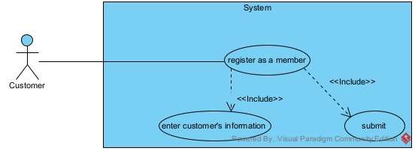
b.
Ques2:
a.Entity Extract
- User: username, password, role, fullName
- ManagementStaff
- Customer: address, phone
- SaleStaff
- DeliveryStaff
- Invoice: date, totalPrice, status
- InvoiceGood: amount, price
- Supplier: name, phone, address
- Good: name, unit, price, description
- ImportGood: amount, price
- ImportInvoice: date, totalPrice
b.
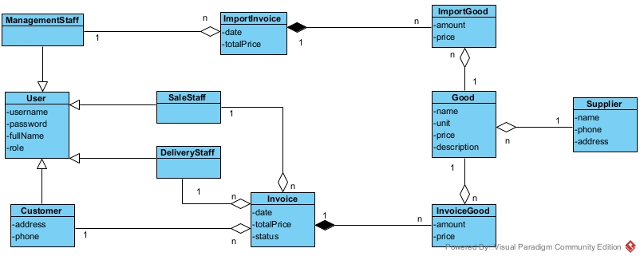
Ques3:
a.
b.
Ques4:
a.
b.

